AWS IAM User-Group Creation
Objectives:
- Simplify Access Control Group users with similar roles or responsibilities to assign permissions collectively instead of individually.
- Enhance Security Reduce the risk of privilege creep by ensuring users only inherit permissions relevant to their group.
- Scalability Prepare for growth by structuring groups in a way that can easily accommodate new users, teams, or projects.

Step 1 — IAM Dashboard

- Log in to AWS Console as the root or admin user.
- Search for "IAM" in the top search bar and open the service.
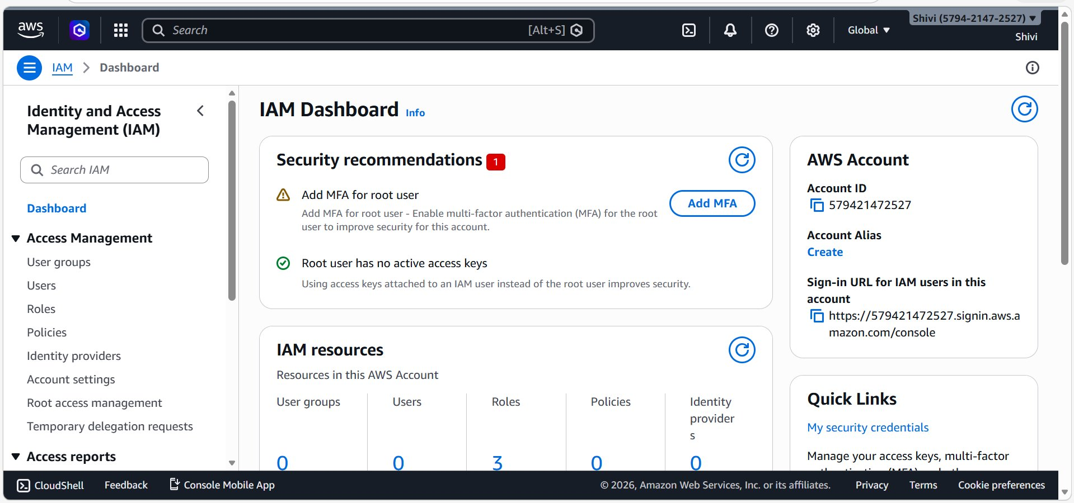

Step 2 — Users Page

- In the left sidebar, click "Users" under Access Management.
- Confirm the list is empty — "No resources to display".
- Click the "Create user" button to begin.

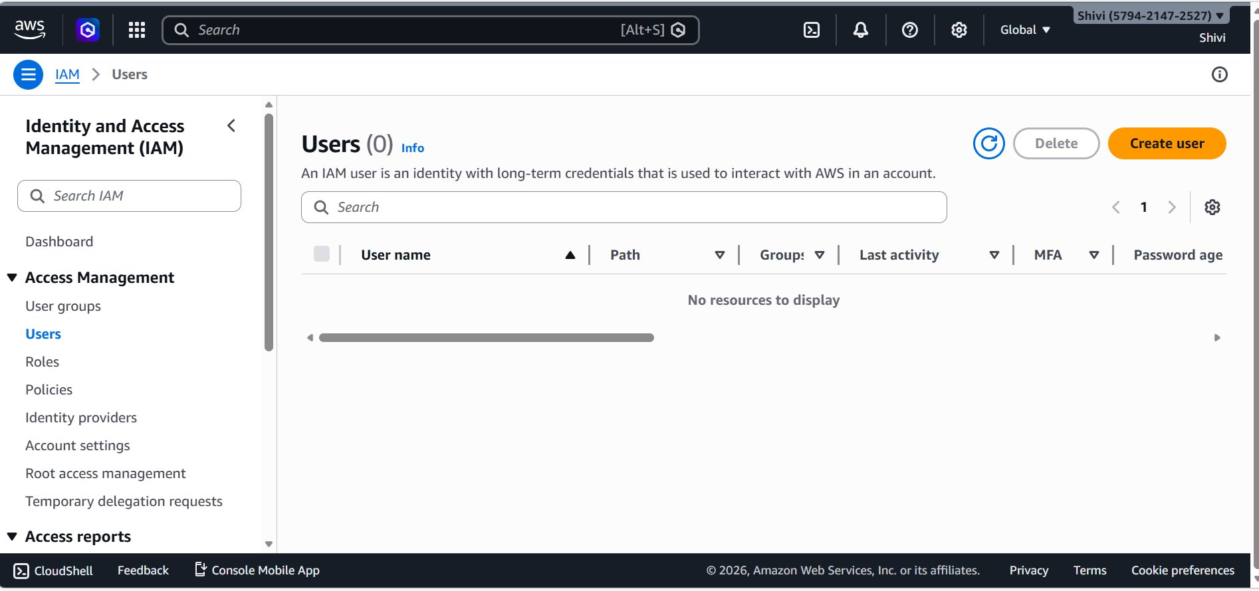

Step 3 — Create User 1 — Specify Details (shivi-s3a)

- Enter username
- Check "Provide user access to the AWS Management Console" — optional but enabled here.
- Select "Custom password" and enter a strong password.
- Leave "Require password reset" unchecked.
- Click "Next" to proceed to Set Permissions.
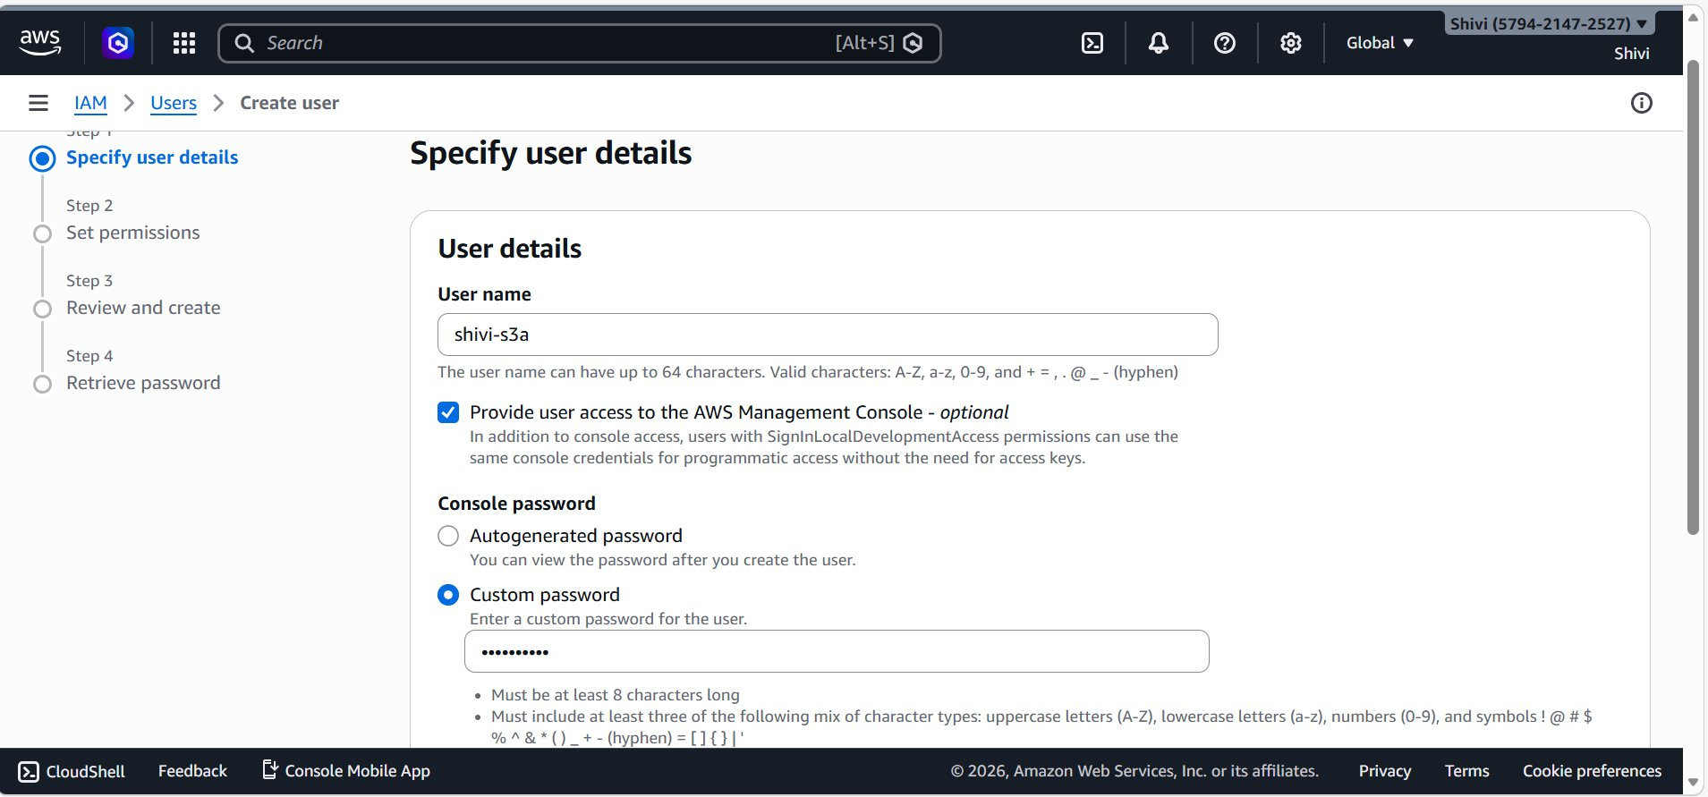

Step 4 — Set Permissions — Attach Policy to user1

- Select "Attach policies directly" as the permission option.
- Tick the checkbox next to "AmazonS3FullAccess" (AWS managed policy).
- Click "Next" to review.
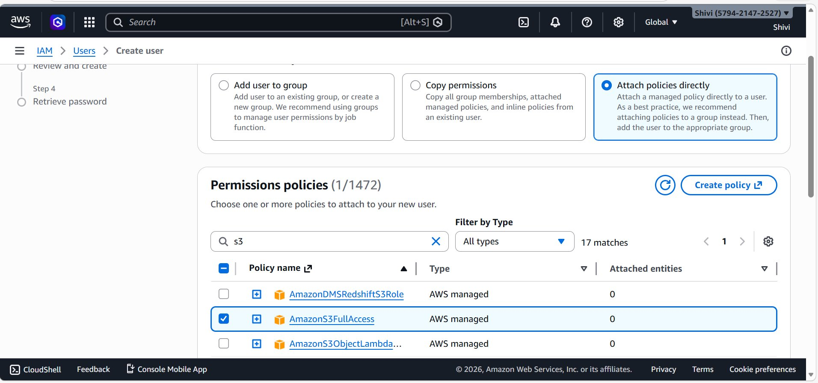

Step 5 — Review & Create — user1

- Verify: Username = shivi-s3a
- Verify: Console password type = Custom password
- Verify: Require password reset = No
- Verify: Permissions — AmazonS3FullAccess (AWS managed, Permissions policy)
- Click "Create user" to complete.

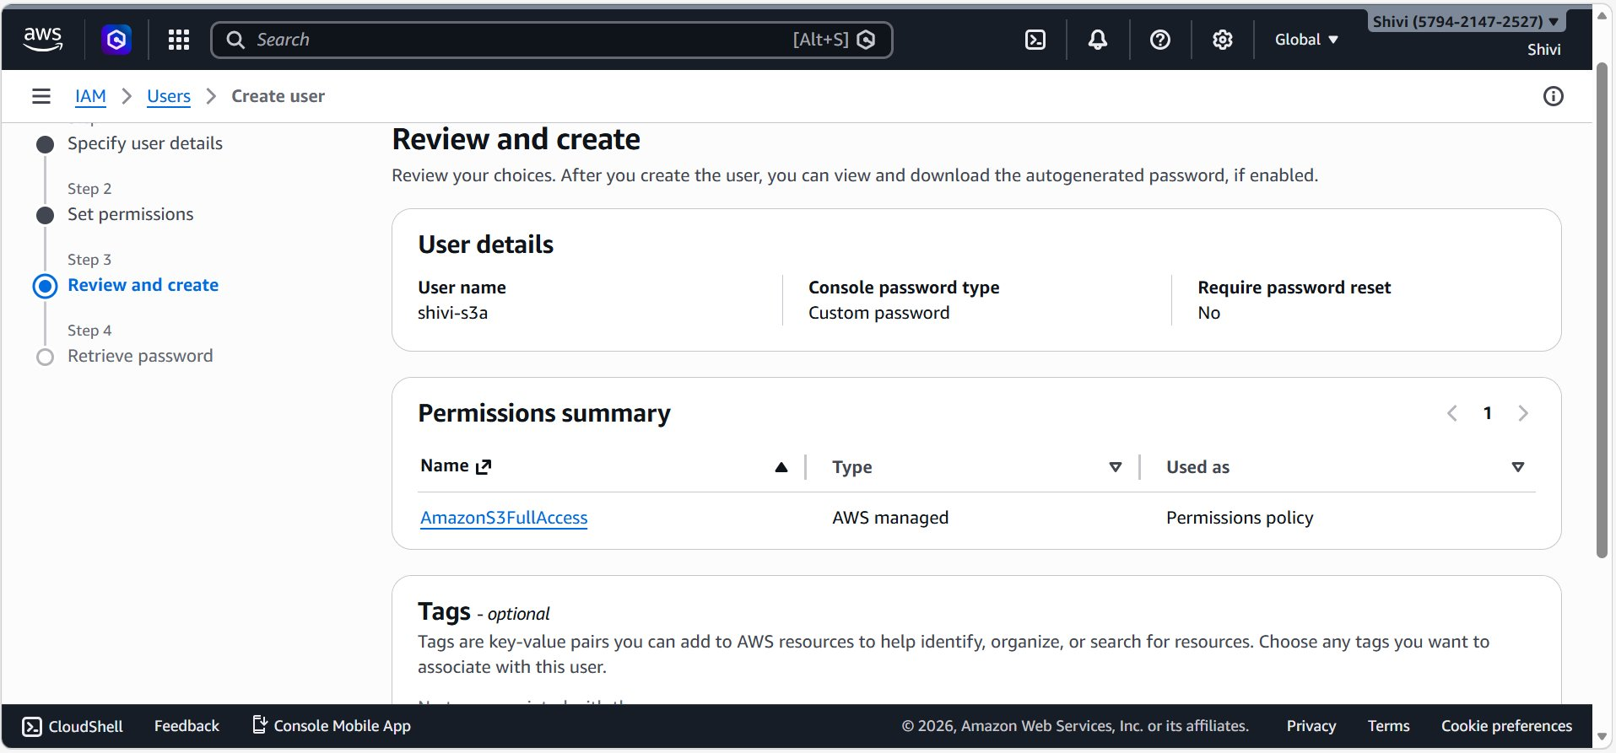

Step 6 — Create User 2 — Specify Details (shivi-s3b)

- Click "Create user" again from the Users list.
- Enter username:
- Check "Provide user access to the AWS Management Console".
- Select "Custom password" and enter the password.
- Click "Next".

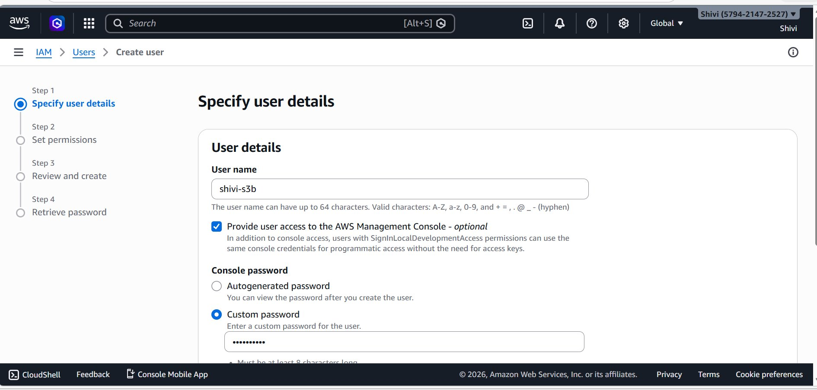

Step 7 — Set Permissions — Attach Policy to user2

- Select "Attach policies directly".
- Search for "s3" and select "AmazonS3FullAccess".
- Click "Next" to go to the review screen.
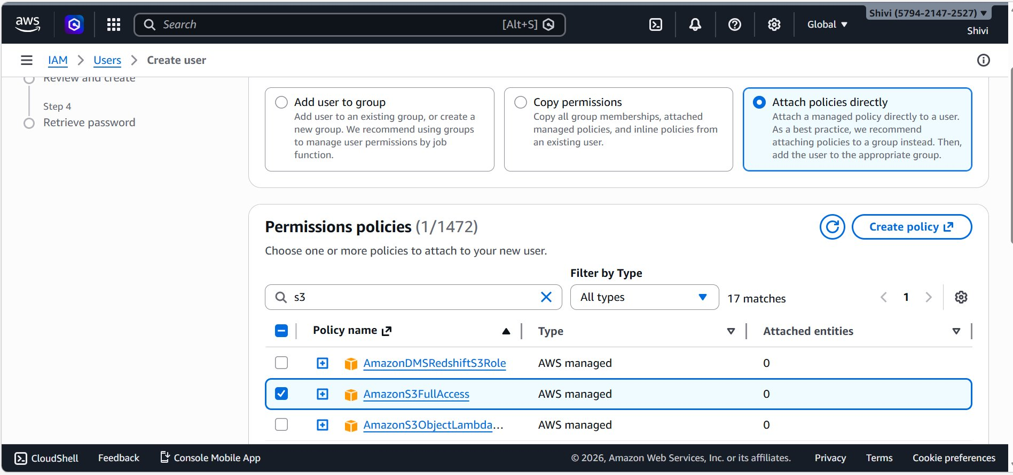

Step 8 — Review & Create — user2

- Verify: Username = shivi-s3b
- Verify: Console password type = Custom password
- Verify: AmazonS3FullAccess policy attached
- Click "Create user".

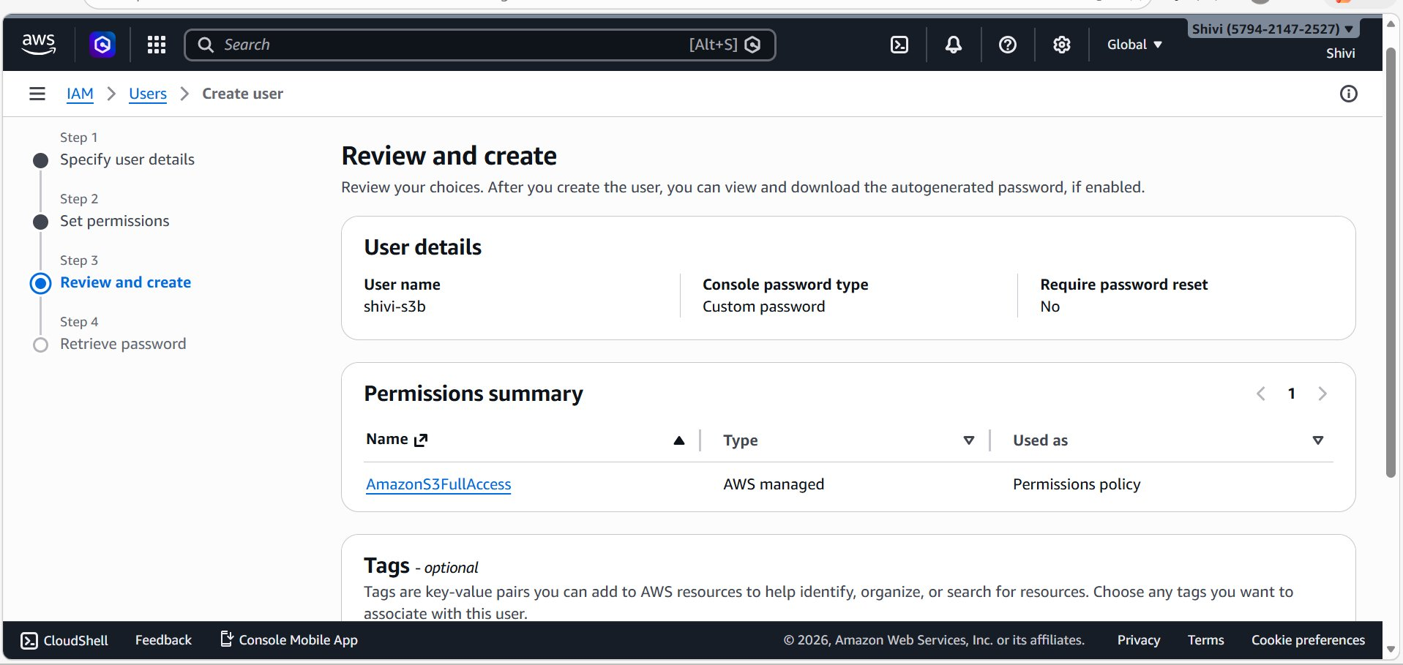

Step 9 — User Groups — Start Creating Group

- In the left sidebar, click "User groups".
- Confirm the list is empty — "No resources to display".
- Click the "Create group" button.

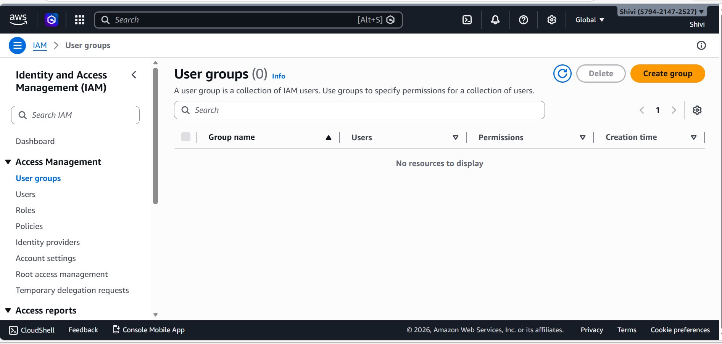

Step 10 — Create Group — Name & Add Users

- Enter group name: nidhi
- In "Add users to the group" section, both users appear in the list.
- Check both shivi-s3a and shivi-s3b (2/2 selected).
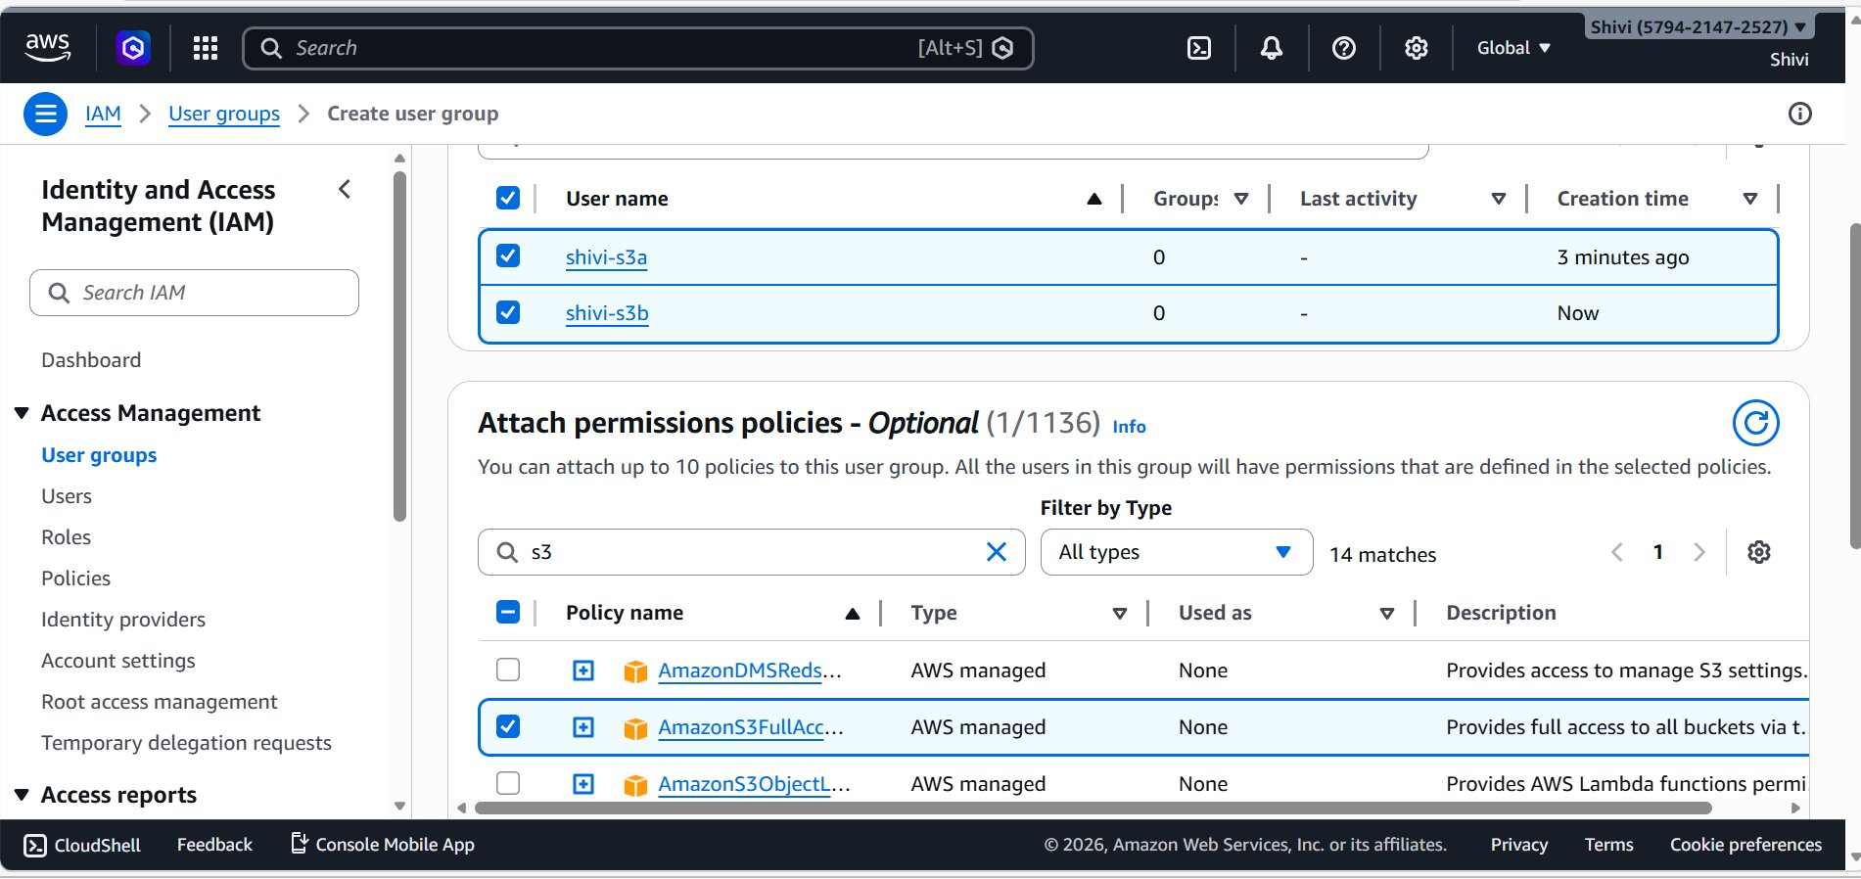

Step 11 — Attach Policy to Group — AmazonS3FullAccess

- Scroll down to "Attach permissions policies".
- Search for "s3”
- Select "AmazonS3FullAccess"
- Click "Create group" to finalize.
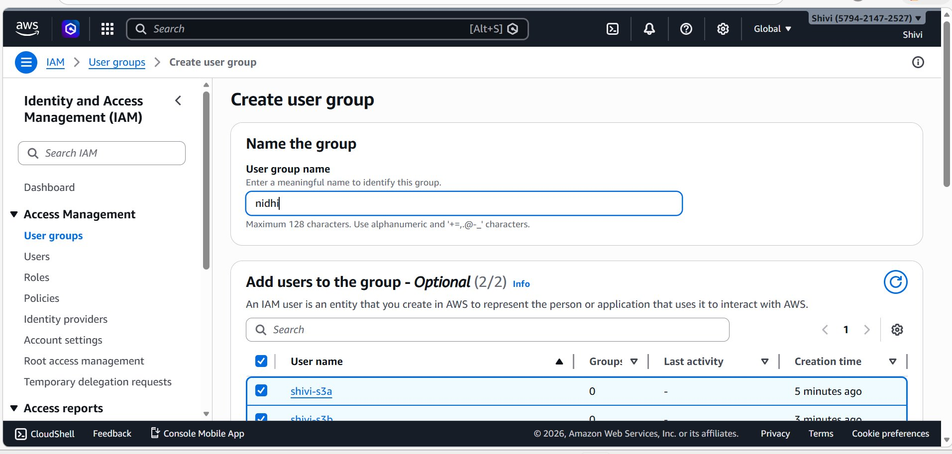

Step 12 — Group Created

- Group name: nidhi
- Users: 2 (shivi-s3a and shivi-s3b)
- Permissions: Defined — AmazonS3FullAccess
